FRED BRYANS LEADERSHIP DEVELOPMENT PROGRAM

Our Vision

The Fred Bryans Leadership Development Program is intended for new and future leaders in the Department. Potential participants will be identified by the Department or Division Head, with preference given to faculty members already in leadership positions, as well as the future leaders within the department. The goal is to build on current skills that will prepare them for present or future leadership roles. The UBC Department of Obstetrics & Gynaecology is grateful to Jane Bryans for her support of this program.
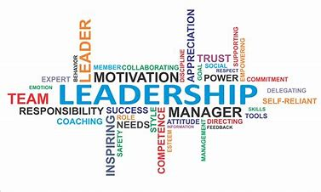
Commitment

In an effort to facilitate participation, all events will be scheduled throughout 2 full days on 4 April and 1 May. The sessions will be held at MSAC. Participants are expected to actively participate in 100% of all sessions.

Who Should Attend

This will be a small group. They will be made up of faculty with leadership potential and faculty who have recently taken on leadership positions. The cohort is by invitation only at this time.

How to Register

Please register your interest in attending this program by emailing Beata Chami: bchami@providencehealth.bc.ca.

Session Schedules

THURSDAY, APRIL 4, 2019
Time | Session | Facilitator
08.00 | Welcome Breakfast & Introduction to the Program/Welcome | Dr. Geoffrey Cundiff
08.45 | Strengths Finder | Maura Da Cruz & Julie Stockton
10.30 | Break
10.45 | Coaching Conversations 101 | Maura Da Cruz & Julie Stockton
12.00 | Lunch
12.45 | Mindful Leadership | TBD
1.30 | Transitioning into Leadership and the Complexity of the Role | Michelle Berner &  Dr. Gavin Stuart
3.00 | Break
03.15 | Emotional Intelligence &  Communicating Effectively | Tom Scholte

WEDNESDAY, MAY 1, 2019
Time | Session | Facilitator
08.00 | Conflict Resolution | TBD
10.30 | Break
10.45 | Navigating the Complexity of Academic Medicine | Dr. Geoffrey Cundiff
Noon | Fundraising | Dr. Dianne Miller
1pm | Lunch
1.45 | Gender, Intercultural Inclusion &  Bullying in the Workplace | Dr. Gurdeep Parhar, Paul Gill & Paul Wong
3.15 | Break
3.30 | Strategic Leadership | Dr. Geoffrey Cundiff
4.30 | Feedback Session & Happy Hour | All

